Cultural Strategies Overview (January 2026)

Contents
Introduction 2
Resources 5
R1. Models and Approaches 5
R2. Findable and Sharable 19
R3. Access and Context 20
R4. Structure and Language 29
R5. Methods and Consultation 34
R6. Themes and Priorities 40
R7. Policy and Position 49
R8. Geographies and Boundaries 53
R9. Living and Responsive 55
R10. Continuity and Evaluation 59
R.11 Success and Failure 66
R12. Network and Share 67

Introduction
This document includes all the content and templates from the twelve recommendation sections of the Cultural Strategies Think Kit up to January 2026. The Think Kit is released under Creative Commons CC-BY-NC-DD 4.4 (Attribution-NonCommercial-NoDerivatives) and can be cited as: Daniel Ashton and Ian Leete (2025) Cultural Strategies Think Kit. DOI: 10.5258/SOTON/P1237.

This document has not undergone the same level of accessibility checking as the website and the resources and templates. Please see the accessibility statement.

The following table provides an overview of each Think Kit section/recommendation and what is included:

Recommendation | What is included in the Think Kit?
Models and Approaches  We recommend a detailed analysis of ‘local authority’ and ‘culture trust’ approaches and processes and how they overlap, differ and align. | An interactive ThingLink with three prompt questions that lead to a series of information boxes that include further questions and examples.  Three downloadable examples of briefs/tenders
Findable and Sharable  We recommend creating an accessible database of strategies as a resource for insight and reflection | A link to the Cultural Strategies Dataset - an online dataset with 217 documents that was last updated September 2025. Links to previous versions of the dataset (a spreadsheet; an online database).
Access and Context  We recommend cultural strategies are created and published following accessibility guidelines and explicitly ensure the accessibility of text and images, provide information on publication and authorship, and provide credit and attribution for content included. | An interactive quiz with ‘yes/no’ questions will help you assess the information required to contextualise and make a cultural strategy accessible. After you have completed the questions, you will receive an indication of the progress made towards ensuring accessibility and contextualisation.  A link to the Examples PowerPoint.
Structure and Language  We recommend identifying what the different parts of a strategy do and how they come together, and elaborating on what frequently used terms (e.g., aim, vision) cover and do. | An interactive ThingLink introduce some of the typical elements/sections that might be included within a cultural strategy and provide elaboration on some of the terms.  A link to the Examples PowerPoint.
Methods and Consultation  We recommend cultural strategies provide information for all data sources that clearly indicates the dataset being used and why and provide details on any consultation processes. | The Cultural Strategies Consultation Planning Checklist is a downloadable Word Document with prompt questions.  The Cultural Strategies Data Overview Template is a downloadable Excel Spreadsheet with column headings to help you add and structure the information on the datasets you are using.  A link to the Examples PowerPoint.
Themes and Priorities  We recommend reflecting on changes and continuities in cultural strategy themes and priorities by engaging with a wide range of cultural strategies that can provide insight across a variety of years and places. | An interactive ThingLink introduces the six main themes and their sub-themes identified through a content analysis of strategies and some examples of the language and terminology.
Policy and Position  We recommend cultural strategies go beyond providing a reference list of policies and strategies that are referred to and create a matrix or table that includes all the policies and strategies referred to and indicates when they were published, if they are timebound, and how long they remain in alignment. | The Cultural Strategies Policy and Position Template is a downloadable Excel Spreadsheet with column headings to help you add and structure the information on the policies and plans you are referring to. The chart enables comparison of how different materials align over time.  A link to the Examples PowerPoint.
Geographies and Boundaries  We recommend that the development of cultural strategies give attention to changing geographies and boundaries and make connections with different ‘neighbours’ to explore cultural strategy alignment and the pursuit of common purpose. | The Cultural Strategies Explorer is an interactive map that enables you to identify which places have cultural strategies and where they exist at different levels (e.g. local and regional), and from this begin conversations.
Living and Responsive  We recommend cultural strategies are made accessible using digital technology platforms that enable updates, responses and continued consultation, and that exploring the features and characteristics of different technological platforms could support wider engagement in a greater variety of ways. | An interactive ThingLink with four prompt questions that lead to a series of information boxes that include further questions and examples.
Continuity and Evaluation  We recommend new cultural strategies, where applicable, reference relevant past strategies to reflect and evaluate on the status of their aims and going forward establish a way for aims to be regularly reflected on and evaluated. | The Cultural Strategies Continuity Flowchart is a downloadable Word document with coloured boxes and linking arrows to help make connections and evaluate continuity between different cultural strategies over time.
Success and Failure  We recommend that the ongoing evaluation of cultural strategies emphasise sharing learning and experiences and transparently reflecting on what was intended and what could be done differently. | An Insights and Reflections series is in development to share learning and experiences.
Network and Share  We recommend exploring the value of a cultural strategies network to share experiences, insights and suggestions. | The Cultural Strategies Network was launched in November 2025. Current activities include bi-monthly online meetings and a LinkedIn Group.

Resources

R1. Models and Approaches
We recommend a detailed analysis of ‘local authority’ and ‘culture trust’ approaches and processes and how they overlap, differ and align.
Partnership is a defining feature in the development, operation and evaluation of a cultural strategy. There is though variety in the structures used for different stakeholders/interested parties to come together to initiate, resource and evaluate cultural strategies.
In the following ThingLink, three prompt questions lead to a series of information boxes that include further questions and examples.
Interactive content for Recommendation 1. Models and Approaches
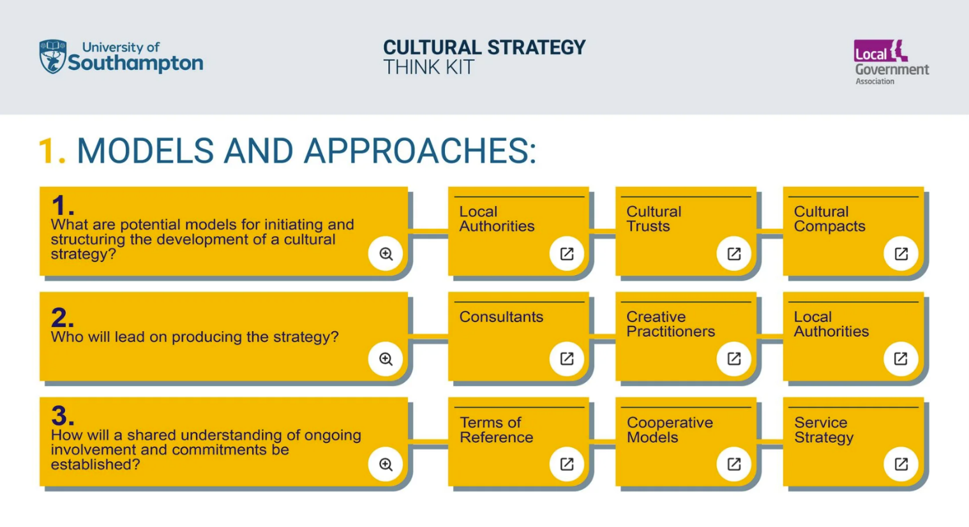
- What are potential models for initiating and structuring the development of a cultural strategy?
Cultural strategies are initiated/commissioned and coordinated in a variety of ways. Research for Cultural strategies and futures identified local authorities and culture trusts as the main drivers behind cultural strategies. Where both local authorities and cultural trusts operate, different forms of partnership and different responsibilities were identified.
The following presents some models with considerations and examples for who leads on initiating and structuring the development of a cultural strategy.
- Local Authorities
Overview
The structure of local government varies from area to area. In most of England, there are 2 tiers – county and district – with responsibility for council services split between them. In total there are 317 local authorities in England made up of 5 different types.
(Source: https://www.gov.uk/guidance/local-government-structure-and-elections)
Considerations here include:
- Local Government Reorganisation and changes to local government structures from 2025 onwards.
- Where ‘culture’ sits within a local authority and how it is connected with other portfolio areas.
Examples
Examples of cultural strategies that have been developed by Local Authorities based on publication from 2020 and still being current:
Examples of Local Authority led cultural strategies
County councils | Derbyshire Cultural Framework
District councils | Basingstoke and Deane Cultural Framework
Unitary authorities | Vibrant Shropshire – Cultural Strategy for Shropshire
Metropolitan districts | Oldham Cultural Strategy
London boroughs | Richmond Upon Thames
Combined Authority (CA)
Overview
A combined authority (CA) is a legal body set up using national legislation that enables a group of two or more councils to collaborate and take /collective decisions across council boundaries. Ten combined authorities have been established (May 2025).
(Source: https://www.local.gov.uk/topics/devolution/combined-authorities)
Examples
The current situation (Summer 2025) shows two Combined Authorities with cultural strategies:
Combined Authority cultural strategies
Greater Manchester | https://www.greatermanchester-ca.gov.uk/what-we-do/culture/creategm/  https://www.greatermanchester-ca.gov.uk/media/1980/strategy.pdf
West of England | https://www.westofengland-ca.gov.uk/about-us/our-strategy/cultural-compact/  https://www.westofengland-ca.gov.uk/wp-content/uploads/2022/02/West-of-England-Cultural-Plan.pdf
Cambridgeshire and Peterborough | Not available
Liverpool City Region | Not available
North East Combined Authority | Not available
South Yorkshire | Not available
Tees Valley | Not available
West Midlands | Not available
West Yorkshire | Not available
- Cultural Trusts
Overview
There are number of charity/trusts structures connected with cultural strategies:
A Trust is an independent non-profit-organisation.
Charitable trusts and foundations are charities with an independent and sustainable income source. They use their assets in pursuit of their mission: primarily through grant-making, as well as investments and sometimes advocacy and campaigning.
(Source: https://acf.org.uk/acf/ACF/About_Us/Guide_to_charitable_trusts_and%20_foundations.aspx)
A Charitable Incorporated Organisation (CIO) Is an incorporated structure designed for charities.
A CIO is created by registering with the Charity Commission. You do not need to register with Companies House. Trustees have limited or no liability for CIO debts or liabilities.
(Source: https://www.gov.uk/setting-up-charity/structures)
Considerations include:
- The legal and financial requirements and implications of the different trust and charity structures
- The long-term availability of funding/income for cultural trusts to resource staff, websites, etc.
Examples
Cultural strategies that have been developed by a Cultural Trust include:
- Culture Chelmsford
‘Following the publication of a Strategy in 2018 and a dedicated Action Plan, Chelmsford City Council established an independent Cultural Development Trust (now known as Culture Chelmsford), appointed Marc De’ath as Chelmsford City Culture Services Manager at the end of 2019 and set about working with its communities to launch a Cultural Forum (Ignite Chelmsford) as well as and facilitating the creation of a Shared Cultural Vision “Towards 2040”.’
Cultural strategies that have been developed by a Charitable Incorporated Organisation (CIO) include:
- Plymouth Culture
‘Plymouth Culture is an independent charity, a Charitable Incorporated Organisation (CIO). We receive core funding from Arts Council England (ACE) as a National Portfolio Organisation (NPO), aligning our work to the ACE’s Strategy “Let’s Create” https://www.artscouncil.org.uk/lets-create) We also receive core funding from Plymouth City Council as a strategic partner and lead for arts and culture in Plymouth.’
- Cultural Compacts
Overview
Compacts are partnerships designed to support the local cultural sector and enhance its contribution to development, with a special emphasis on cross-sector engagement beyond the cultural sector itself and the local authority.
(Source: https://www.artscouncil.org.uk/review-cultural-compacts-initiative).
Considerations include:
- The convening and facilitating role of certain compact members/contributors
- The capacity of differently resourced and sized compact members/contributors and the implications of this for shaping agendas and diversity of perspectives and experiences
Examples
Examples of a Cultural Compact leading on a cultural strategy:
- Sheffield Culture Collective
‘Sheffield Culture Collective is the name of Sheffield’s Cultural Compact. We published our Strategy Document on 17th June 2021. Our strategy explains how we intend to bring our vision to life and deliver significant outcomes for our city over the next 10 years.’
- Birmingham Cultural Compact
‘The Birmingham Cultural Compact seeks to co-create and co-deliver a holistic vision for culture in Birmingham. Our vision is part of a step change in the sustainability and contribution of culture to the life of the city. It will link the cultural sector to broader aspirations and priorities for Birmingham and secure partnerships between the cultural sector and other sectors’
One of the stated functions is to:
‘To refresh and develop the creative & cultural industries elements of the Birmingham Cultural Strategy and contribute towards the delivery of the regions Creative Industries Strategy’
Other formations exist which focus on partnership but do not use the term ‘compact’. Example of this is include:
- All the Wonder (The Isle of Wight Cultural Strategy 2023–2033)
‘It has been developed by Creative Island (formerly The Island Collection) through a process involving over 500 people and organisations and has been adopted by the Isle of Wight Council.’
- Culture is our plan (Bradford District 2021-2031)
‘The Bradford Cultural Place Partnership commissioned Culture Is Our Plan with funds from City of Bradford Metropolitan District Council and Arts Council England. The Partnership is chaired by Cllr Susan Hinchcliffe and membership includes leaders of the major strategic cultural initiatives in the District alongside representatives of the independent arts, culture and heritage sector:
- Arts Council England
- Bradford 2025 UK City of Culture Bid
- Bradford College
- Bradford Cultural Education Partnership
- Bradford Producing Hub
- City of Bradford Metropolitan District Council - Cultural Voice Forum
- The Leap, Creative People and Places programme, led by Bradford Institute for Health Research
- National Lottery Heritage Fund
- University of Bradford
The independent sector representatives are nominated by the Cultural Voice Forum, a network open to everyone working in arts, culture and heritage in our District. It brings together more than 250 people to share sector knowledge, experience and opportunity.’
- Who will lead on producing the strategy?
Alongside the resources needed for the cultural strategy development activity (e.g., partnership, co-creation, conversations and consultation), producing the public cultural strategy is a considerable undertaking. This will include structuring the strategy and creating/curating the content (text, images).
Whatever form the strategy takes, it is essential to prioritise accessibility and there should be transparency and visibility for those involved in the writing, editing, etc. and credit for all materials included (e.g., photographs). See recommendation three on access and context and recommendation four on structure and language.
The following presents some considerations and examples for who leads on producing the strategy.
- Consultants
Overview
The first annual survey of cultural strategies in England in January 2023 identified 30 (out of 147) cultural strategies in which cultural consultants were identified (Source: Ashton and Bell (2023) Cultural strategies and futures).
Considerations include:
- Who will commission and brief the consultants? Examples of briefs and tenders are available on the Model and Approaches page.
- Who will fund the consultancy project and manage the payment?
- What, if any, relationship do the consultants have to the cultural strategy? What are the benefits and challenges of having a local/regional consultancy who are embedded within the areas compared to having a more detached perspective?
Examples
Examples include:
Place | Strategy | Consultant
Basingstoke & Deane Borough Council | Time out: A framework for culture in Basingstoke and Deane | Counterculture
Allerdale Borough Council | A Cultural Strategy for West Cumbria | CTConsults
- Creative Practitioner
Overview
Creative practitioners may feature within a cultural strategy through their projects and activities and through illustrative and decorative images. Another connection can be in the production of the actual cultural strategy.
Considerations include:
- Where there is a relationship between a local authority and freelance creative practitioners?
The Bridging the Gap: Connecting local government with creative freelancers policy brief from the Diverse Capacities project shares recommendations addressing make opportunities visible and commissioning processes . Arts Council England has a resource here that includes Fair Pay and Equitable working conditions.
- Which aspects will creative practitioners be involved with and how do they combine? For example, co-creation and consultation; producing the strategy; ongoing evaluation?
- How long would the engagement be and how can security and sustainability around this work/commission be enabled?
Examples
Place | Strategy | Creative Practitioners
Wigan Borough Council | The Fire Within | Al and Al
Derbyshire County Council | Derbyshire Cultural Framework | Curated Place
- Local Authority
Overview
A cultural strategy can be within the remit for one or several portfolios or teams. Portfolios titles and the areas they bring together can vary (e.g. arts, culture, economy, events, place, tourism). As explored under recommendation 7 (Policy and Position), a cultural strategy can be aligned with and connected to the diverse range of local authority corporate plans.
Considerations include:
- Which departments/teams will be involved?
- Is there a process for strategy approval?
- How will different strategies and corporate plans align?
- Any specific local authority guidelines on writing style and web publications. For sector guidance, see Local Government Association (LGA) writing style guide.
Examples
The Cultural Strategies database includes strategies which give insights into the role of and connections between council departments/directorates. For example:
Place | Strategy | Notes
Brighton and Hove | Brighton and Hove Cultural Strategy | The welcome from David Smith (Cabinet Member for Culture, Recreation & Tourism)  references the Corporate Plan.
West Cumbria | A Cultural Strategy for West Cumbria | Cross-references plans for West Cumbria, Carlisle, and Cumbria.
- How will a shared understanding of ongoing involvement and commitments be established?
Once the strategy has been made public, there may a review of who continues to be involved and how. For example, a larger partnership involved in development might transition into a smaller group. This question closely connects to questions of delivery and governance and recommendation ten on continuity and evaluation.
The following presents some approaches to establish and maintain clarity on ongoing commitments.
- Terms of Reference
Overview
A Terms of Reference document is used to define and outline the purpose and structures of a project, partnership, relationship, etc.
Considerations include:
- Who is on this group and how are they appointed to it?
- Is this as a representative for an organization and/or as a specific person involved for what they bring (expertise, connections, etc.)?
- Do these rotate?
- How is it resourced?
Examples
Examples include:
- Birmingham Cultural Compact
- Sheffield Culture Collective
- Cooperative Models
Overview
Cooperative models variously take inspiration from cultural democracy and sociocratic approaches and emphasize inclusive membership and collaborative decision-making.
Considerations include:
- How the governance models and specifics of place align. For example, the local and/or historical connections to cooperative approaches.
- How is the cooperation facilitated?
Examples
- Newcastle Creates
Governance
‘Newcastle Creates has cultural democracy at its heart. We want people from all backgrounds and organisations to join us and develop a truly collaborative, cross sector approach to setting the agenda for culture in the city. Newcastle Creates is a cooperative, owned by its members, each of whom has a say in what it does and how it does it. Every member has a vote on resolutions presented at its general meetings. Operating as a co-operative gives us the chance to remove the barriers associated with invitation-only or sector specific networks. We are building a collaborative, community-based model for cultural development that will prioritise learning, sharing, exchanging and partnering.
Our directors will be elected by members annually, to ensure that Newcastle Creates is representative of, and accountable to, the people who live and work in the city and have an interest in its culture. Members are invited to four general meetings a year and to the Annual General Meeting. These meetings give members the opportunity to give feedback, put forward proposals, help shape the strategic direction and vote on resolutions put forward by the Board.’
- Rochdale Creates
Governance
‘Rochdale's Cultural Compact is an innovative initiative designed to strengthen and elevate the cultural sector across the borough. The Compact, which is currently administered by the RDA [Regional Development Agency] Culture & Placemaking team, brings together diverse stakeholders to harness the power of culture in driving local development.
The compact is rooted in inclusivity and sociocracy, ensuring that all voices are heard and that decision-making is collaborative. this structure allows the compact to remain agile and responsive, adapting to the changing cultural landscape in Rochdale while keeping the community at its hearts.’
- Service Strategy
Overview
A Service Strategy approach focuses on the role of a local authority. Whilst the importance of partnership may be evidence, the emphasis in the strategy is on setting out the role of local authority and connecting into established reporting on mechanisms.
Considerations include:
    - How does a local authority focused service strategy connect with and create a space with other driving factors?
    - What does a local authority reporting structure enable and limit?
Examples
    - A Creative Gravesham
‘To ensure that this strategy remains relevant and focused it will be reviewed regularly, action plans will be drawn up annually and the reporting of results will be part of the council’s annual review. Responsibility for developing the action plans and monitoring delivery will be led by the Cultural Manager with support from the Service Manager, Customer & Theatre Services. Regular reporting of progress will be made to the Council’s Management Team and to the Cabinet Member for Community and Leisure.’
    - Nottinghamshire County Cultural Strategy
‘Our Cultural Strategy sets out a clear, coherent and comprehensive overview of why Nottinghamshire County Council provides and supports, both directly and indirectly, a range of cultural services for the people of Nottinghamshire and the many visitors who are attracted to the County.

The Cultural Strategy will deliver the vision of the Council through four key themes that reflect the cultural issues facing the County.

The progress of the Cultural Strategy and the Service Cultural Action Plans will be monitored and reviewed on an annual basis and reported to Council.’
      - Westmorland Cultural Framework
‘I am pleased to share our Cultural Framework which sets a new direction for Westmorland and Furness Council’s work in and with culture, arts and heritage in our area for our economy, our communities, and environment.’
‘This Framework is an initial piece of work which aims to set the direction of travel for Council-led and Council-supported culture, creativity and arts, identifying the immediate actions to kickstart this work.’
‘The aims of the Cultural Framework is to identify the Council’s priorities for culture; align the delivery of culture in which the Council invests with the strategy and principles of Arts Council England’s ‘Let’s Create’, and Creative People and Places programme, and the Council’s own Community Power strategy; and act as a catalyst for conversation, partnership-brokering, place-making, collaborative working and investment in culture, ensuring efforts and resources are co-ordinated and focused.’

R2. Findable and Sharable
We recommend creating an accessible database of strategies as a resource for insight and reflection
The creation of a database has gone through several iterations.
The current version is an online dataset with 217 documents that was last updated September 2025.
- Cultural Strategies Dataset
Think Kit resource 8 (geographies and boundaries) is a companion map which enables: (1) searching across time for a specific place (2) searching the different geographic scales for place (3) references to themed layers (e.g., Arts Council).
To make suggestions to the Dataset (e.g., additions; updates; addressing inaccurate information), please complete this Microsoft Form (hosted by the University of Southampton).
Version 1 was an Excel Spreadsheet that is available here (last update January 2023)
Version 2 was an Online Database that is available here (last updated May 2024)

R3. Access and Context
We recommend cultural strategies are created and published following accessibility guidelines and explicitly ensure the accessibility of text and images, provide information on publication and authorship, and provide credit and attribution for content included.
The following ‘yes/no’ questions will help you assess the information required to contextualise and make a cultural strategy accessible.
After you have completed the questions, you will receive an indication of the progress made towards ensuring accessibility and contextualisation.
For some questions there will be a link to an external resource that can assist with understanding the suggestion.
The results are not saved. The quiz can be completed multiple times.
The quiz is divided into two parts:
- Part 1: Resource for Access
Accessibility: Images, Text and Visual Design
- Do you add alternative text to all images, icons, and charts? [This allows people who use screen readers to understand visual content.] For further guidance see: Alternative Text
☐ Yes
☐ No
- Do you choose text and background colours with enough contrast? [Good contrast makes reading easier for everyone, especially users with low vision]. For further guidance see: Contrast Checker
☐ Yes
☐ No

- Do you avoid using colour alone to show meaning (such as red for “no” and green for “yes”)? [This supports people with colour blindness or visual impairments]. For further guidance see: Designing in a colour-blind world
☐ Yes
☐ No
- Do you allow users to enlarge text without losing content or layout? [This helps people who need larger text to read comfortably]. For further guidance see: W3C: Resize Text
☐ Yes
☐ No
- Do you avoid using text in images when possible? [Screen readers cannot read text inside images.]
☐ Yes
☐ No
Accessibility: Audio and Video
- Do you include captions or a transcript for all videos? [Captions support users who are deaf or hard of hearing.]
☐ Yes
☐ No
☐ N/A
- Do you provide a transcript for audio-only content? [Transcripts provide access for users who cannot hear audio content.]
☐ Yes
☐ No
☐ N/A
- Do you avoid content that flashes more than three times per second? [Flashing content can cause seizures or discomfort for some users.] For further guidance see: W3C: Avoiding Seizures
☐ Yes
☐ No
☐ N/A
Accessibility: Navigation and Interaction
- Do you let users move through all content using a keyboard? This is essential for users who cannot use a mouse. For further guidance see: WebAIM: Keyboard Accessibility
☐ Yes
☐ No
- Do you make sure the selected item is clearly visible when using a keyboard? [A visible focus helps users know where they are on the screen.] For further guidance see: WebAIM: Keyboard Accessibility
☐ Yes
☐ No
- Do you include a way to skip repeated content (such as a “Skip to main content” link)? [This improves navigation for screen reader and keyboard users]
☐ Yes
☐ No
Accessibility: Document Structure and Layout
- Do you place all images in line with the text (not floating or wrapped)? [This ensures screen readers follow the correct reading order.]
☐ Yes
☐ No
- Do you use built in heading styles (Heading 1, Heading 2, etc.) to structure your content? [Heading styles help screen reader users navigate the content efficiently. For further guidance see: Microsoft: Heading Styles
☐ Yes
☐ No
- Do you use headings in a logical order without skipping levels? [A clear heading structure helps all users understand the layout.]
☐ Yes
☐ No
- Do you use tables only for data, not layout? [Screen readers expect tables to hold structured data, not for visual layout.] For further guidance see: WebAIM: Accessible Tables
☐ Yes
☐ No
- Do you add a clear header row to each data table? [Header rows help screen reader users understand what each column means.]
☐ Yes
☐ No
- Do you avoid using merged or split cells in tables? [Merged cells can break the reading order and confuse screen readers.]
☐ Yes
☐ No
- If you use shapes in Word (Windows), do you place them inside a Drawing Canvas and add a caption or alt text? [This helps keep the content structured and accessible.] For further guidance see: Microsoft: Adding a drawing to a document
☐ Yes
☐ No
- Do you keep the layout consistent across all pages or sections? [Consistency helps users know where to find information.]
☐ Yes
☐ No
Accessibility: Language and Forms
- Do you use clear, direct language and avoid jargon? Plain English helps everyone, including non-native speakers and users with cognitive impairments. For further guidance see: UK Gov: Writing for Accessibility
☐ Yes
☐ No
- Do you label all form fields clearly and include helpful instructions where needed? [Clear labels help users complete forms accurately.]
☐ Yes
☐ No
- Do you write link text that makes sense on its own (for example, “Download timetable” not “Click here”)? [Descriptive links help users using screen readers or keyboard shortcuts.] For further guidance see]: W3C: Link Purpose
☐ Yes
☐ No
Accessibility: Files and Formats
- Do you run the Accessibility Checker in Word, PowerPoint or Excel? [The checker helps you find and fix common accessibility issues.] For further guidance see: Microsoft: Accessibility Checker
☐ Yes
☐ No
- If you create a PDF, do you run the Adobe Accessibility Checker? [This helps you identify and fix accessibility issues in PDF files.] For further guidance see: Microsoft: Creating accessible PDFs
☐ Yes
☐ No
- Do you tag your PDF so screen readers follow the correct reading order and structure? [Tagged PDFs are essential for accessibility and navigation.]
☐ Yes
☐ No
- Do you give documents and download links clear and descriptive names (for example, “Annual Report 2024 (PDF)”)? [This helps users understand what they are downloading before they click.]
☐ Yes
☐ No
- Do you offer key information in other formats (such as large print, plain text or audio) if needed? [Alternative formats support users with a range of access needs.]
☐ Yes
☐ No
Accessibility: Support and Contact
- Do you provide clear contact details for users who may need information in a different format? [Some users may need large print, audio, plain text, or another format to access your content. Offering a point of contact allows them to request support easily.]
☐ Yes
☐ No
Further Guidance:
- UK Government: Accessibility Requirements
- Microsoft: Accessible Content and Experiences
- Microsoft: Explore Accessibility tools
- AbilityNet: Digital Accessibility Free Resources
- W3C: Introduction to Web Accessibility
- WebAIM: Introduction to Web Accessibility
- Part 2: Resource for Context
The following questions focus on the context for developing a cultural strategy and providing important information on when it was created, how it was created and who was involved.
- Is the year of publication of the cultural strategy provided?
☐ Yes
☐ No
- Is the period of time covered by provided?
☐ Yes
☐ No
- Is a link to a permanently archived version of previous strategies provided?
☐ Yes
☐ No
- For images of artwork, events, projects, etc. included in the cultural strategy is credit provided for (a) the photographer/designer of the image and (b)the actual artwork, events, project, etc. in the image?
☐ Yes
☐ No
- Is the design and artwork for the strategy itself credited?
☐ Yes
☐ No
- Is authorship, including (a) the input of consultants and (b) consultation and/or collaborative authorship, explained?
☐ Yes
☐ No
As an additional resource, the below PowerPoint presentation includes examples of how cultural strategies have provided information and credit related to contributions and materials used. All strategies can be accessed via the dataset available from Think Kit Resource 2.
- Access Examples PowerPoint
Further considerations and suggestions
- Undertake an Equality Impact Assessment (see UK Parliament Guidance overview and a one-minute guide from Leeds City Council)
- Extend accessibility considerations to other interactions linked to the strategy (for example, co-creation and consultation events)
- Engage user communities and individuals in reviewing materials with consideration to paying for involvement (see The Social Change Agency Guidance)
- Commission creative practitioners (artists; photographers; etc.) in generating the content and assets used within a strategy and address the terms for (ongoing) usage and/or discrete payments
- Consider the diversity of images and representations
- Review use of Artificial Intelligence in creating content (for example, Arts Council England Guidance on internal usage)
- Create an easy read version (see UK Association for Accessible Formats Guidance)
- Connect to and align with relevant accessibility design policy (e.g. internal to a local authority)
- Review and plan for ongoing resource commitments to ensure access and accessibility.

R4. Structure and Language
We recommend identifying what the different parts of a strategy do and how they come together, and elaborating on what frequently used terms (e.g., aim, vision) cover and do.
The following boxes introduce some of the typical elements/sections that might be included within a cultural strategy and provide elaboration on some of the terms. Their inclusion and order will vary based on local context. Some of the elements/sections might be included within the appendix.
Interactive content for Recommendation 4. Structure and Language.
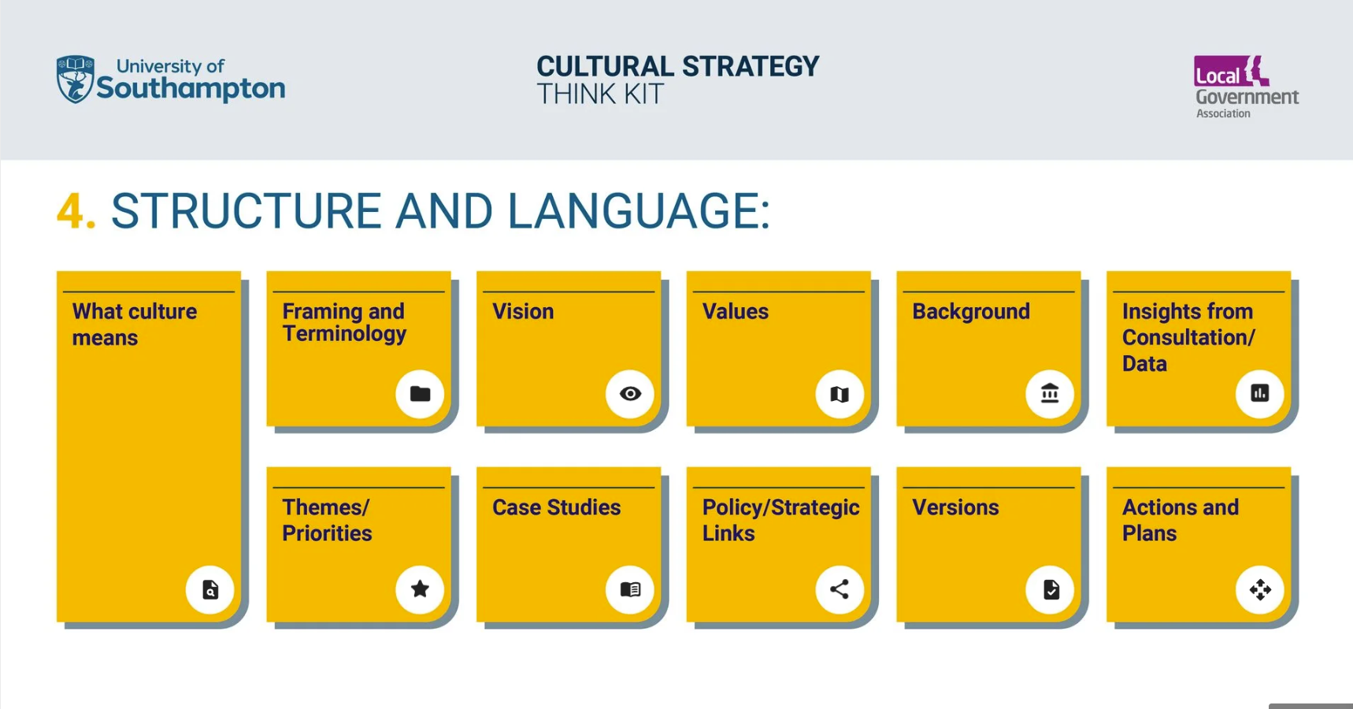
What culture means
Exploring how ‘culture’ is being defined and approached can enable a shared starting point and understanding. Creating this requires considering who will engage with the strategy and why. This could also be an opportunity to make connections and relations to other areas (see Think Kit resource 7 on ‘themes and priorities’).
Framing and Terminology
There can be variety in the terms used relating to ‘culture’ and ‘strategy’. This may be shaped through: co-creation and consultation processes; local and regional context; national policies.
Research underpinning the Cultural Strategies and Futures report and used for an earlier version of the database gives some indication on:
- The choice or combination of terms. For example: arts; culture; cultural; creative; creative economy; heritage.
- The terms being used to describe what is being created. For example: plan; framework; manifesto; strategy.
(See Column D on this spreadsheet hosted by the University of Southampton)
Closely linked to this, a glossary could provide a summary of terminology and acronyms used in the strategy.
Vision
Cultural Strategy in a Box suggests that a vision should be ‘a single clear sentence or very short paragraph at the beginning of the strategy that states the council’s future goal for the area, achievable through the action plan in your cultural strategy.’
Values
Values are beliefs that guide what is important and how actions and choices are approached.
Background
There is the opportunity to introduce the place(s) where the cultural strategy focuses. It could also be an opportunity to look back at previous strategies and reflect on success or areas that will carry on.
Cultural strategies can speak to different types of audiences (e.g., communities; cultural and creative sector organisations and practitioners; funders; local authorities).
There are also important decisions to be made on the use of a foreword and who provides this.
Insights from Consultation/Data
As recommendation 7 from Cultural Strategies and Futures explores, there is variety with the ‘evidence and data sources and datasets being referenced within cultural strategies’ and ‘this includes the use of existing data sources and sets (e.g., Audience Agency; Department of Culture, Media and Sport Taking Part survey) and bespoke surveys and consultation for the strategy.’
A typical element/section within a cultural strategy is to introduce the consultation and data analysis process and summarise the insights.
Think Kit resource number 5 on ‘methods and approaches’ explores how to provide details on consultation processes.
Themes/Priorities
Cultural strategies often identify specific themes that are identified through co-design consultation and connect with variety of points of reference (e.g., national policy; local plans).
Culture and Place in Britain (Key Cities, 2023: 62) suggested that ‘looking at the overall picture, the strategies of places differ in local content and priorities but there are no big changes in overall trends between those adopted a decade ago and newly developed ones.’
Think Kit resource 6 on ‘themes and priorities’ shares some of the themes that feature in existing cultural strategies.
Case Studies
Cultural activities, events, organisations often appear throughout a strategy to provide local relevance and meaning.
There are important decisions to be made on the which cultural activities, events, organisations are mentioned and to what extent (e.g. mentions within a sentence or prominent case study boxes).
As Think Kit resource number 3 on ‘access and context’ addresses, all materials should be created and have permissions.
Policy/Strategic Links
As recommendation 7 from Cultural Strategies and Futures explores, ‘a consistent approach within cultural strategies is to reference and align to policy.’ This can be national and local policies, strategies, plans, etc.
Think Kit resource number 7 on ‘policy and position’ develops this recommendation with suggestions on how to identify relevant points of reference and align them to the lifespan of the strategy.
Versions
Closely linked to Think Kit 9 ‘living and responsive’, it might be an option to have two different and complementary versions:
- A ‘top level’ strategy, which remains unchanged for the planned life span of the strategy
- A delivery plan, which provides the detail on specific plans, actions, changing policy contexts, etc.
Actions and Plans
The themes and priorities are often translated into specific actions. There is considerable variety in the language that could be used here (actions; goals; aims; objectives; milestones; targets) and this will likely be shaped by the different contexts related to the strategy. This is part of the picture explored with Think Kit resource 1 on ‘models and approaches’.
Recommendation 10 focused on how aims can be regularly reflected on and evaluated in the future, and Think Kit resource 10 on ‘continuity and evaluation’ gives examples of how this has been done and a template with prompts.
The question of who has responsibility for coordinating the overall progress in relation to these actions and how this is done is addressed with Think Kit resource 1 on ‘models and approaches’.
The aims/actions can be pitched at different scales, and this can have implications. For example, if they are too vague can they be effectively evaluated. Or, if they are too precise or granular does this limit flexibility and/or lead to reporting burdens and capacity issues. The priority is clarity and transparency around the what the aims/actions are and how they translated into meaningful action that can be reflected on and evaluated.
As an additional resource, the below PowerPoint presentation includes examples of how cultural strategies have been structured and the different language used for different sections/elements. All strategies can be accessed via the dataset available from Think Kit Resource 2.
Access Examples PowerPoint

R5. Methods and Consultation
We recommend cultural strategies provide information for all data sources that clearly indicates the dataset being used and why, and provide details on any consultation processes.
The Cultural Strategies Consultation Planning Checklist is a Word Document with prompt questions focusing on:
  - Consultation Aims and Design
  - Ethical Considerations and Data Protection
  - Data Generation, Analysis and Sharing
For each of these areas there are suggestions for resources.
Download Checklist

Cultural Strategies Consultation Planning Checklist
Title:
Click or tap here to enter text.
Date Checklist Prepared: Click or tap to enter a date.
Checklist Prepared by:
- Consultation Aims and Design
Question | Resources and skills to address this | Ideas
What is the overall research design or approach?
Who will participate and what is required to enable their access and participation?
What specific questions will be engaged with?
Do these questions align with existing consultation, surveys etc. from your and neighbouring area?
Prompts and Suggestions:
Based on the needs identified in the resources and skills column, are there local and regional organisations (e.g. universities) which could contribute?
What can approaches centring co-creation, citizen-led and creative methods enable? (See suggested resources and references)
Can consultation methods initially be piloted with a smaller group?
Is accessibility and inclusivity embedded in the approach and the materials (Think Kit Resource 2 on access and structure might help here)

Suggested Resources and References:
The Audience Agency (2020) Creating an Effective Audience Development Plan. Available at: https://theaudienceagency.org//asset/2157 (Accessed: 16 May 2025).
Local Government Association (2025) Engagement – how to involve and understand residents. Available at: https://www.local.gov.uk/our-support/communications-and-community-engagement/engagement-how-involve-and-understand-residents (Accessed: 16 May 2025).
Cabinet Office (2018) Consultation principles: Guidance, GOV.UK. Available at: https://www.gov.uk/government/publications/consultation-principles-guidance (Accessed: 30 May 2025).
Citizens in Power (n.d.) Resources. Available at: https://www.citizensinpower.com/resources (Accessed: 30 May 2025).
Cultural Value (2024) Evaluation Principles. Available at: https://www.culturalvalue.org.uk/our-work/evaluation/evaluation-principles/#eval (Accessed: 16 May 2025).
Migration Museum (2023) A toolkit for co-created community engagement projects. Available at: https://www.migrationmuseum.org/wp-content/uploads/2023/11/Migration-Museum-Peoples-Tool-Kit_compressed.pdf (Accessed: 16 May 2025).
Wright, R. (2017) The consultation charter - the 7 best practice principles. Available at: https://www.consultationinstitute.org/consultation-charter-7-best-practice-principles/ (Accessed: 16 May 2025).

- Ethical Considerations and Data Protection
Question | Resources and skills to address this | Ideas
What are the ethical guidelines relevant for generating this data?
Will informed consent be obtained?
Will participant anonymity/confidentiality be ensured?
How will data be stored securely and comply with data protection regulations (e.g., GDPR)?
Has an Equality Impact Assessment been considered for the consultation process?
Suggested Resources and References:
Museums and Heritage (2017) Advisor free webinar GDPR - and what you need to know - the resources. Available at: https://museumsandheritage.com/advisor/posts/advisor-webinar-general-data-protection-regulation-need-know/(Accessed: 16 May 2025).
Museums Association (2024) Code of ethics for museums. Available at: https://www.museumsassociation.org/campaigns/ethics/code-of-ethics/# (Accessed: 16 May 2025).
The Public Sector Equality Duty (PSED) | EHRC (2022) The Public Sector Equality Duty (PSED). Available at: https://www.equalityhumanrights.com/guidance/public-sector-equality-duty-psed (Accessed: 16 May 2025).
- Data Generation, Analysis and Sharing
Question | Resources and skills to address this | Ideas
What methods will be used?
Facilitation Plan and Timeline: (Facilitators; Required Resources)
How will data be analysed?
How will findings be documented and shared?
Alongside the analysis and any reports, will anonymised data be made available? If so, how?
Suggested Resources and References:
Christou, E., Owen, V. and Ceyhan, P. (2023) The little book of creative evaluation, The Little Book of Creative Evaluation. Available at: https://creativeevaluation.uk/ (Accessed: 16 May 2025).

The Cultural Strategies Data Overview Template is an Excel Spreadsheet with column headings to help you add and structure the information on the datasets you are using.
Download Template
No. | Data Source Title | Commissiong Organisation | Link/Reference | Type | Date Collected / Published | Relevance Period | Reason for use in this strategy | Notes
1 | Taking Part | Department for Culture, Media and Sport | https://www.gov.uk/guidance/taking-part-survey | National Survey | 2022/2023 | Annual | [e.g., Provides national benchmark for engagement] | [e.g., Access via specific URL/report]
3 | Audience Answers | Audience Agency | https://evidence.audienceanswers.org/en | Sector Data | 01/05/2024 | Ongoing | [e.g., Insights into local arts audiences] | [e.g., Requires subscription]
4
5
6
7
8
9
10
11
12
13
14
15
16
17
18
As an additional resource, the below PowerPoint presentation includes examples of how cultural strategies provide information for data sources used and consultation processes. All strategies can be accessed via the dataset available from Think Kit Resource 2.
Access Examples PowerPoint

R6. Themes and Priorities
We recommend reflecting on changes and continuities in cultural strategy themes and priorities by engaging with a wide range of cultural strategies that can provide insight across a variety of years and places.
The research for the Cultural Strategies and Futures report involved a content analysis of the 147 cultural strategies archived in January 2023. Information on the process are available here and the archive is available here.
This resource introduces the six main themes and their sub-themes identified through the content analysis and shares some examples of the language and terminology.
Interactive Content for Recommendation 6. Themes and Priorities
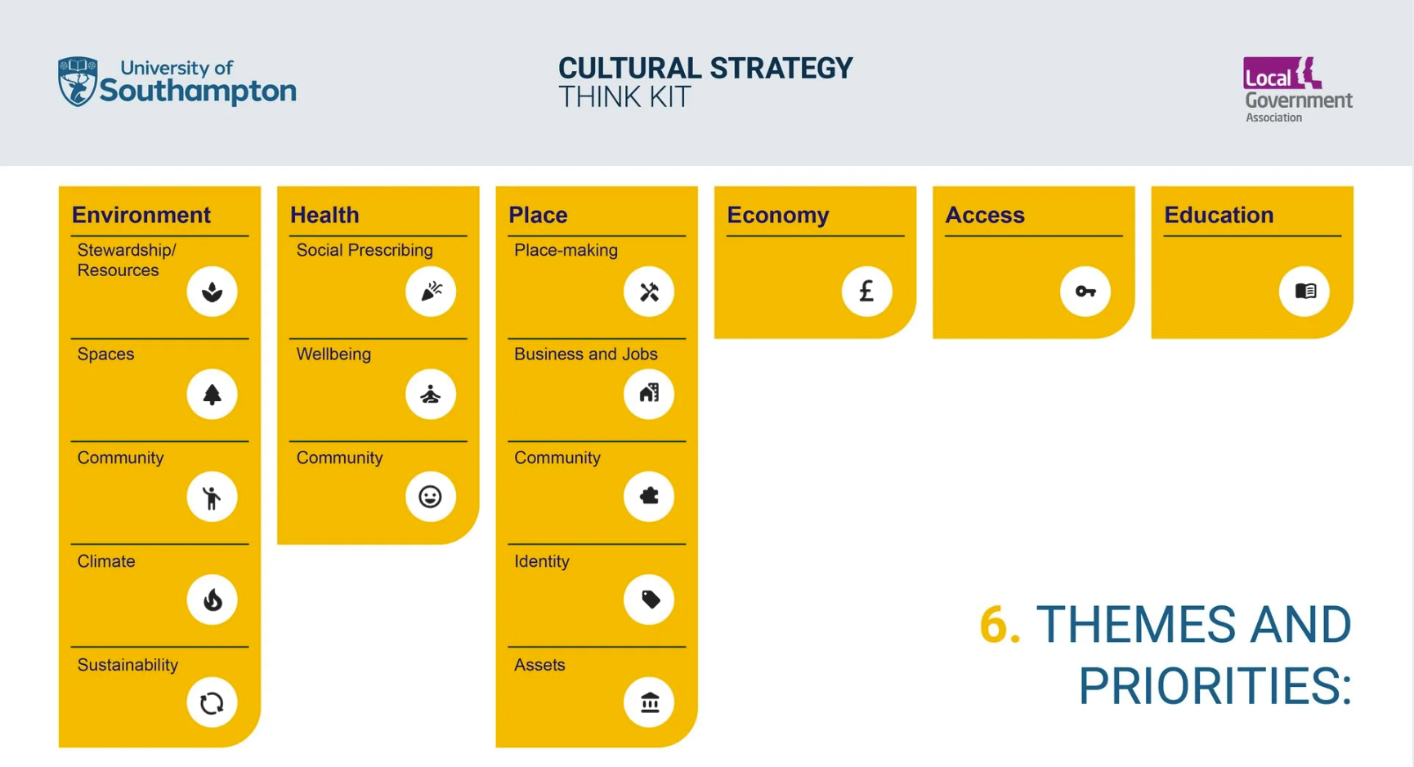
Environment
- Stewardship/Resources
“Encourage engagement in and enjoyment of the river and canal through active leisure and volunteering for conservation projects” – Bath and North East Somerset, 2011-2026.
- Spaces
Highlighting green assets
“Littlehampton could make more of its waterfront assets by developing, managing and promoting the waterfront as a destination and by investing more in the gardens and promenade, which are tired.” – Arun, 2013-2028.
Accessibility of green spaces
“Open up more opportunities in parks and open spaces for local community events” – Barnet, 2018.
Intricately linking environment into programming and activities
“Support outdoor programmes to grow and actively encourage sponsorship and participation from neighbouring commercial partners” – City of London, 2018-2022.
- Community
“Get communities more involved - promote usage, community involvement and participation of parks and, where appropriate, explore and formalise how residents and stakeholders can actively participate in the maintenance and development of these spaces” - Hounslow, 2016 – 2020.
- Climate
The role of culture
“Culture has a vital role to play in connecting people to the natural environment and leading the way in addressing issues of climate change and environmental sustainability.” – Colchester, 2022-2030.
From change to emergency
”The Strategy recognises the need to respond positively to the challenges and opportunities that may arise through climate change.” - Woking, 2004
“We will be a city of culture with green credentials, using culture and creativity to tackle the climate emergency.” – Plymouth, 2021-2030.
Specific steps
“The cultural sector will reduce its carbon footprint in Dorset, help change public behaviour to reduce environmental impact (both locally and globally) and support communities to develop sustainable and regenerative responses to the climate and ecological emergency.” – Dorset, 2021-2026.
- Sustainability
General statements on inspiring action
“Artists of every kind will lead, influence, advocate, and inform policy to create change for sustainable living.” – Newcastle, 2022-2030.
Behavioural change and specific ways of pursuing cultural activities and programming
“Encourage sustainable food production and consumption by local residents • Support ‘grow your own’ initiatives and allotments” – Bracknell Forest, 2008-2012.
Developing skills
“Sustainability matters for Chelmsford, with its natural landscapes and growth ambitions. Delivery of the Strategy respects and connects with landscaped and wild spaces and protects the natural world through training and developing the creative sector to be exemplary in ecological sustainability. Create and co-deliver to develop their creative skills.” – Chelmsford, 2023-2033.
Health
- Social Prescribing
- No mentions of social prescribing until 2018.
- Strategies published in 2020 contain 44.94% of all mentions of social prescribing.
- 14.6% of mentions of social prescribing occur in a single strategy published in 2020.
“Arts in Health: We will establish Doncaster as a centre of excellence for the delivery and integration of arts and health programmes across a wide range of health and social care needs, including the innovative and exciting field of Arts on Prescription.” – Doncaster, 2020-2030.
- Wellbeing
Positive Impact
“Cultural services are key to health improvement and central to the promotion of a healthy lifestyle. This is not only physical health but also mental health and wellbeing” - Three Rivers, 2002-2007.
Specific framework, policy and commission contexts
“Harrow Council’s work with Lateral (Strategic Commissioning and Adult Social Care) to build community capacity and resilience” - Harrow, 2018-2021.
Partnerships and approaches
“Work with partners to tackle obesity within the borough through leisure and cultural activities with particular focus on the areas with highest instances.” – Basildon, 2020-2025.
- Community
“Creativity will be a positive force for health and well-being, for building connectivity and communities where everyone can participate.” - Newcastle, 2022 - 2030.
Place
- Place-making
“The first strategy had a theme ‘Enhance town centres throughout’. The importance of regenerating Bracknell Town Centre is well recognised. Crowthorne and Sandhurst also have town centres and so were included in this theme. However, this did not acknowledge the role that the rural villages and urban neighbourhoods play in creating a sense of place. Therefore, the theme has been broadened to: Enhance town centres, villages and neighbourhoods” - Bracknell Forest, 2008 - 2012.
“Place-making – creating tools and processes that make Salford’s centres and neighbourhoods feel distinctive and open with a sense of clear identity” – Salford, 2020 - 2030.
“Creative Placemaking: We will ensure creative placemaking, so that cultural infrastructure, creative workspaces and resident programmes are integral to planning and regeneration schemes.” – Westminster, 2021 - 2025.
- Business and Jobs
Workforce, talent and skills
“The primary aim is to develop existing and attract more workforce talent, especially young, early-career people, actively choosing to work in the creative and cultural industries in West Cumbria in order to progress their creative and cultural ambitions, rather than as a lifestyle choice such as semi-retirement. And to be able to sustain viable, valued careers in West Cumbria.” – Allerdale and Copeland, 2022 - 2027.
Generating business opportunities/growth
“Creative Businesses: planning and investment to respond to growth builds on the importance of the commercial creative sector in and around Cambridge, and sets out how best to ensure that cultural and arts bodies might play a more integrated role in the wider knowledge economy. Accessible, affordable workspace, knowledge transfer and showcasing activities are some of the key activities to strengthen and sustain this fast growing part of the sub-region’s commercial and cultural economy.” – Cambridge Sub-Region, 2006.
- Community
Consultation and decision-making
“Provide opportunities for our communities to engage with and inform cultural output – engendering a strong sense of ownership, pride of place and widening participation” – City of London, 2018- 2022.
Building community
"Building a strong spirit local community spirit – strength of community spirit is one of the principal aims of the Community Strategy, and culture has a key role in defining a positive identity for the Borough that the community wants to associate with. Cultural activities can bring together people from all sections of the local community, irrespective of age, ethnic origin or wealth.” – Woking, 2004 - 2009.
Celebrating community creativity
“Every community is empowered to grow and sustain its own cultural activity – bringing to life the unique identity of each place and community.” – Calderdale, 2022 - 2032.
- Identity
“Local community and civic leaders must recognise that “culture = participation” as much as “culture = consumption”. An individual’s sense of agency (i.e. their ability to make decisions about their lives) is as important as the services they receive. Top down cultural interventions (such as “I love Worthing” signage) should be replaced by a programme of bottom-up identity building.” - Adur and Worthing, 2016.
“Establish across Hastings a dynamic cultural ecology that fosters a sense of pride, belonging and identity” – Hastings, 2022 - 2027.
“Heritage and culture promote a sense of identity, providing a focus for growing strong communities and individuals who feel empowered to make choices that affect their lives and giving people a feeling of belonging to a place.” - Warwickshire, 2020 - 2025.
- Assets
“Developing venues. Outdoor spaces, festivals, networks, heritage and natural assets to create a vibrant, high quality community centred ecosystem.” – East Lindsey and Boston, 2022 - 2025.
“Cultural facilities such as museums and libraries contribute to the cultivation of attractive, vibrant, busy places that people can enjoy in safety.” – Ealing, 2013 - 2018.
“Realise capital projects that will rehouse, reimagine and repurpose the District’s cultural and heritage assets” – Bradford, 2021 - 2031.
Economy
“The Strategy supports measures to stimulate the evening economy of the town centre, and proposes working with town centre management, commercial operators, community safety partners and others to widen the non alcohol-based entertainment for people in the town centre.” – Woking, 2004.
“To build high levels of cultural participation. Tendring has high levels of deprivation. A more inclusive economy, with lower levels of deprivation, happens where people feel able to engage with the world around them. Participative cultural activity builds engagement, improves employability, and reduces deprivation” – Tendring, 2019 - 2024.
Access
“Encouraging Social inclusion – providing fair and equal access and opportunities for people to enjoy and participate in cultural activities, irrespective of their age, ability, income, ethnic background or level of disadvantage.” – Woking, 2004- 2009.
“Improve the quality of our active places, remove barriers to participation and improve access so that everybody in Wigan can access a full range of facilities, information and advice that enables them to have a healthy and active lifestyle.” – Wigan, 2013 - 2023.
“An inclusive creative offer for Wakefield needs to take into account the district’s diverse geography, groups and cultural interests, raise aspirations through access to artistic excellence and ensure access to creative and cultural skills and career pathways. Everyone needs to understand the value of creativity - and feel permitted to be playful!” – Wakefield, 2020 - 2025.
“We want to remove barriers and ensure our community have a wide range of ways to participate in culture, enabling everyone to experience how culture can help to improve wellbeing and make us feel more connected to our place and community” – Southend-on-Sea, 2021 - 2031.
Education
“Enabling Lifelong Learning – providing the opportunity for people to enrich their lives by developing new skills, knowledge or expertise, and new experiences at any stage in their lives.” - Woking, 2004 - 2009.
“Create the environment and the opportunities for local people to explore and unleash their creativity through informal and life-long learning from professional, semi professional and amateur opportunities” – Basingstoke and Deane, 2022 -2032.
“Bring together capacities and resources of the cultural sector to deliver a biosphere-thinking menu of creative curriculum opportunities across subjects from early years, working with schools” – Isle of Wight, 2023 - 2033.
“To work to establish a Local Cultural Education Partnership (LCEP) as the incubator to grow the capacity for creativity in Carlisle with a pilot programme of activity that delivers a universal, inclusive approach to creative education.” – Carlisle, 2020 - 2023.

The content for this resource is being update to: (1) extend from 147 to the 217 strategies now in the dataset (2) review and expand the themes.
As well as identifying how cultural strategies feature related themes and priorities, it is also significant to identify where culture features within other strategies. For example, the West of England Growth Strategy references culture and creativity throughout.
This suggestion links with recommendation/resource seven on policy and position.
Planned updates (October 2025)
Examples of where strategies and plans make explicit reference to cultural strategies.
Review/expand the above six themes.

R7. Policy and Position
We recommend cultural strategies go beyond providing a reference list of policies and strategies that are referred to and create a matrix or table that includes all the policies and strategies referred to and indicates when they were published, if they are timebound, and how long they remain in alignment.
The Cultural Strategies Policy and Position Template is an Excel Spreadsheet with column headings to help you add and structure the information on the policies and plans you are referring to. The chart enables comparison of how different materials align over time.
Download Template
No. | Publisher | Title | Publication Year | Valid until | Timeframe | Type of Reference Document | Type of organisation publishing reference material
1 | Example Local Authority | Example cultural strategy | 2025 | 2031 | 6 | Cultural Strategy | Local Authority
2 | Arts Council England | Lets' Create | 2020 | 2030 | 10 | National Policy | Arm's-length body
4 | National Lottery | National Lottery Heritage Fund Strategy | 2023 | 2033 | 10 | National Policy | National Government
5 | British Film Institute | Screen Culture 2024 | 2023 | 2033 | 10 | National Policy | National Government
6 | Historic England | Championing Heritage, Improving Lives | 2021 | 2031 | 10 | National Policy | National Government
7 | DCMS | DCMS Departmental Overview 2021-23 | 2023 | 2033 | 10 | National Policy | Arm's-length body
8 | Example Local Authority | Annual Library Plan | 2023 | 2024 | 1 | Local Policy | Local Authority
9
10
Important note. The following features can only work in a downloaded version of the Excel worksheet.
Instructions:
- Add your Cultural Strategy to row 1. Additional strategies (e.g. regional level; neighouring areas) could be added as additional rows.
- Cultural strategy documents will automatically be highlighted using purple box.
- Add in 'reference' material (e.g. policies; plans).
- Choose the relevant type of reference document (Column G) and the type of organisation publishing reference material (Column F).
- You can use various sorting functions to analyse the data.
- Sort column A (No) from small to largest to reset the document's order.
- You can add additional rows as needed by using Right-click over the existing cell's template --> insert --> table rows above or below.
- Make sure the formula on Column F and G have all been copied into the new row(s) to enable the drop-down lists.

Legends:
Policy publication year Policy Timeframe
As an additional resource, the below PowerPoint presentation includes examples of how cultural strategies have referred to and aligned with policies and plans. All strategies can be accessed via the dataset available from Think Kit Resource 2.
Access Examples PowerPoint
The Local Government Association’s infographics on ‘The complex landscape of fragmented funding for culture’ and ‘The cultural governance jigsaw’ provide prompts for the policies and points of reference that might be considered.
The Arts Professional article ‘Cultural strategies: Layers of place and policy’ critically explores the challenges and complexities of aligning with multiple policy contexts and points of reference (this article can also be accessed open access on the University of Southampton repository).

R8. Geographies and Boundaries
We recommend that the development of cultural strategies give attention to changing geographies and boundaries and make connections with different ‘neighbours’ to explore cultural strategy alignment and the pursuit of common purpose.
The below Cultural Strategies Explorer map enables you to identify which places have cultural strategies and where they exist at different levels (e.g. local and regional), and from this begin conversations.
The map can be accessed directly the ArcGIS website.
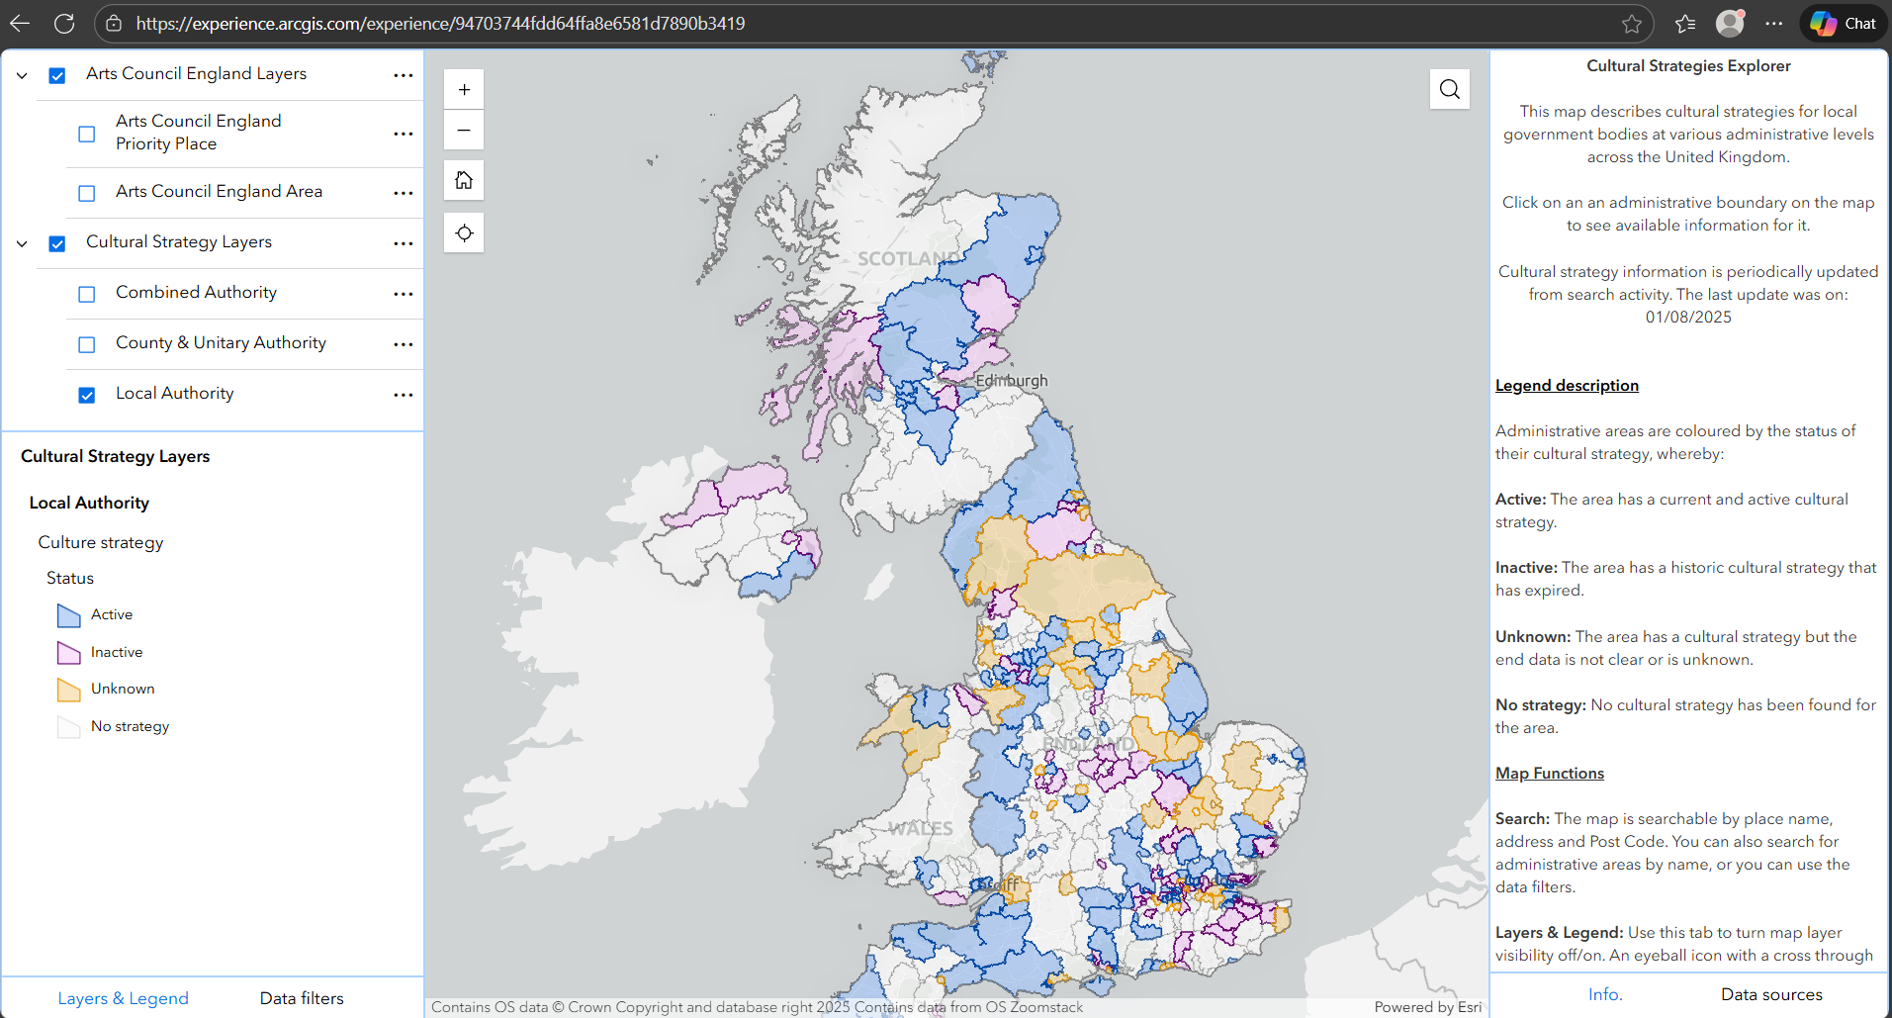
Guidance Video.

R9. Living and Responsive
We recommend cultural strategies are made accessible using digital technology platforms that enable updates, responses and continued consultation, and that exploring the features and characteristics of different technological platforms could support wider engagement in a greater variety of ways.
In the following ThingLink, four prompt questions lead to a series of information boxes that include further questions and resources.
Interactive content for Recommendation 9. Living and Responsive
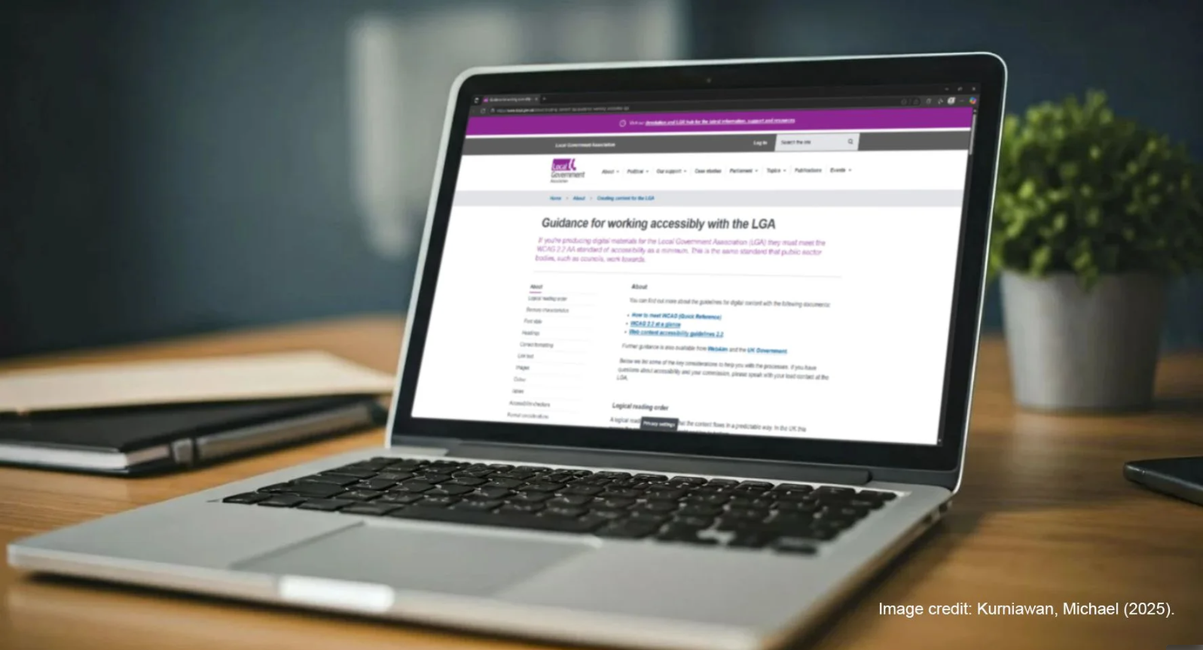
- Where will the cultural strategy be hosted?
- Local Authority website
This will help ensure accessibility and security. See Local Government Association guidance on accessibility requirements for public bodies and on cyber security.
This will have implications for authoring and editing access. If the local authority is part of a collective (see Think Kit Resource on Recommendation 1: Models and Approaches), is there scope for collaboratively authoring and agreeing content?
- An independently hosted website
Accessibility should be carefully and regularly reviewed with reference to Web Content Accessibility Guidelines.
Consider the annual fees (for example, domain name) and a plan for who receives the updates (a shared email account) and is responsible for payments.
This approach may enable more collaborative authoring and editing.
- How will the cultural strategy be accessed and saved?
- PDF (Portable Document Format)
Using a PDF can enable an ‘archive version’. However, research for the Cultural Strategies and Futures report showed that weblinks break and content can be (re)moved. This can be an issue for limiting insights and reflection, and continuity and referencing past strategies (see Think Kit Resource on Recommendation 10: Continuity and Evaluation).
The PDF is also a static document which presents challenges for being able to engage with changes in context and policy (see Think Kit Resource on Recommendation 7: Policy and Position).
There are also issues with accessibility issues to address in exporting from a Word Document to a PDF (see Think Kit Resource on Recommendation 3: Access and Context).
- Website
A website is dynamic and could enable updates on cultural strategy plans and actions (see Think Kit Resource on Recommendation 10: Continuity and Evaluation). Noting the value of an archived version, a suitable approach could be an ‘updates areas’ provided alongside the published/archive version of the cultural strategy. This may be a project management dashboard or a similar approach to reviewing progress in relation to a specific plan and action over time.
Guidance from the Government Digital Service (2018) outlines how, ‘compared with HTML [Hypertext Markup Language] content, information published in a PDF is harder to find, use and maintain. More importantly, unless created with sufficient care PDFs can often be bad for accessibility and rarely comply with open standards.’
- Will the cultural strategy be updated within its stated timeframe?
- Yes
Updating a cultural strategy can be important way to promote an accurate, transparent and meaningful understanding of what is happening and being able to adapt and plan actions (see Think Kit Resource on Recommendation 10: Continuity and Evaluation). Also, as several recommendations in the Cultural Strategies and Futures report highlight, there can be many changes over the proposed lifetime of a cultural strategy that necessitate updates.
- No
The Cultural Strategies and Futures report highlighted 5 years as the most common duration of a cultural strategy. This decision can be shaped by different factors, including alignment with expected changes to other local plans (i.e. local authority corporate plans) and changes in context (i.e. devolution). Whatever the duration, the possibility to update is closely linked to having an accurate, transparent and meaningful understanding of what is happening and being able to adapt and plan actions (see Think Kit Resource on Recommendation 10: Continuity and Evaluation). Whilst the original content might not be edited, it is recommended to establish an approach that ensures a cultural strategy is not left to fossilize and become irrelevant.
- Will continued public engagement and consultation be undertaken and communicated?
- Yes
Research for the Cultural Strategies and Futures report encountered a variety of approaches to consultation and co-design in the development of cultural strategies (see Think Kit Resource on Recommendation 5: Methods and Consultation). A ‘living and responsive’ approach enables ‘interested parties’ of diverse communities, businesses, organisations, etc. to help reflect on what the cultural strategy has enabled and shape its continued relevance.
Practical considerations:
- the resources and methods to enable regular engagement and consultation over the life of the cultural strategy. This could include citizen surveys and assemblies to generate insights and feedback.
- providing regular updates. Possible approaches include (1) a separate ‘action log’ or ‘delivery plan’ which accompanies the strategy (2) a blog (3) updates/reporting on the cultural strategy within related reporting processes (for example, for other local authority strategies).
- identifying those who will coordinate, facilitate and undertake engagement and consultation. This could involve a choice or balance between local organisations with local knowledge and organisations from further afield or consultants who might enable a more detached position?
- a data management plan and data sharing agreement (guidance from Information Commissioner’s Office) relating to materials that are generated on an ongoing basis.
Being able to communicate and share findings from regular public engagement and consultation requires an accessible platform. The plans and approaches developed for this question need connecting to the previous three questions.
- No
The importance of sustained public engagement is established in the Cultural Strategies and Futures report and a variety of other cultural sector contributions:
Centre for Cultural Value Evaluation Principles
Citizens in Power
Engaging with these materials might promote reflections on how public engagement and consultation connects with the local contexts of your cultural strategy.

R10. Continuity and Evaluation
We recommend new cultural strategies, where applicable, reference relevant past strategies to reflect and evaluate on the status of their aims, and going forward establish a way for aims to be regularly reflected on and evaluated.
The Cultural Strategies Continuity Flowchart is a Word document template with coloured boxes and linking arrows to help make connections and evaluate continuity between different cultural strategies over time. For example, where a place has a cultural strategy from 2018-2023 and is developing a cultural strategy for a new time period (i.e., 2025-2030). It can be downloaded, adapted and used.
Download Flowchart Template
Cultural Strategies Continuity Flowchart
The below template is a structure with prompts to make connections and evaluate continuity between different cultural strategies over time. For example, where a place has a cultural strategy from 2018-2023 and is developing a cultural strategy for a new time period (i.e., 2025-2030).
The aim is to make the link between strategies to enable transparent reflection and evaluation.
- Objectives from a previous/current cultural strategy go in the first column/blue boxes.
- Objectives from a previous/current cultural strategy that have been concluded go in the second column/orange boxes, with comments and evidence.
- Objectives from a previous/current cultural strategy that are being continued or revised go in the third column/green boxes as updated objective
The text within the existing boxes can be edited.
New boxes can be added by copying and pasting the different elements (coloured boxes and linking arrows).

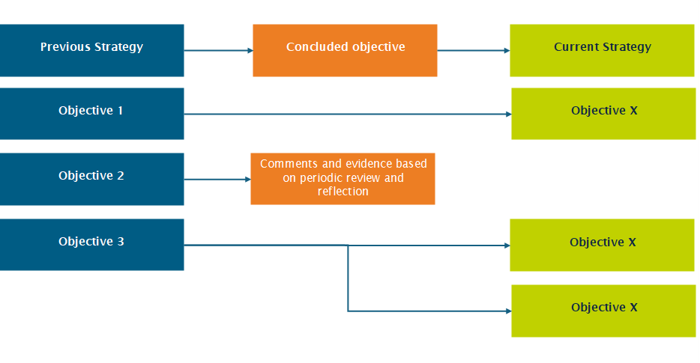
Title: ​Click or tap here to enter text.​ Date: ​Click or tap to enter a date.​

We recommend that new cultural strategies establish a way for aims to be regularly reflected on and evaluated in the future.
The Cultural Strategies Periodic Review & Reflection is a Word document with a suggested structure and prompt questions. It can be downloaded, adapted and used.
Download Review and Reflection Template
This template may be more appropriate as conceptual prompt where existing approaches already exist (e.g., local authority dashboards and evaluation monitoring). Engagement with these existing approaches is essential so that portfolios/areas (i.e., culture and health) and reporting contexts (e.g. UNESCO Creative Cities Network) can connect.

Cultural Strategies Periodic Review & Reflection
Title:
Click or tap here to enter text.
Review Period: Click or tap to enter a date.
Date of Review Meeting/ Report: Click or tap to enter a date.
Responsibility for coordinating responses: [Who is leading and can this be rotated?]
- Progress Review
Alignment to Strategy | Action/Activity | Lead | Progress Indicators | Progress Updates | Related data | Follow up action
[E.g. If there are themes] | [Insert reference/title for action or activity] | [E.g., if a partner or group is leading] | [Insert progress indicators] | [Insert update in relation to action/activity | [Insert data source/evidence and location] | [Add follow up action to revise/replace current progress indicator in next periodic review]
Education and Young People | 1. Establish relationship with secondary schools | Cultural Education Partnership | All five schools in area contacted and added to database for updates from Council newsletter | Four schools added and one school to reply | Database managed by [name] and available at [location] | [Name] to contact remaining school by [date]
 | 2. Support youth-led arts festival | [Names] | [Name] to facilitate feedback from youth organisers | 6/8 youth organisers participated in feedback. Summary report produced | Summary report of feedback prepared by [name] and available at [location] | [Name] to circulate link to report to encourage feedback and recommendations are considered for xxx future events by [date]
Creative Economy | 1. Establish mentorship network for micro-business founded in last 5 years | [Names] | [Name] to coordinate 2 events in [areas] to build the network by [date] | 1 of the 2 planned events completed | Eventbrite posting and attendance figures | [Name] to request further support from [group] in making contact with possible venues.
- Identifying and Reflecting on Achievements and Challenges
Summarise milestones reached and significant successes and challenges with reflections for the future.

Action/Activity | Achievement | Reflections
Education and Young People 1:  Establish relationship with secondary schools | Four out of five Schools added to the database | Using Cultural Education Partnership was an effective way to use existing relationships and coordinate.

Action/Activity | Challenge | Reflections
Creative Economy 1:  Establish mentorship network for micro-business founded in last 5 years | Only 1 event was completed after the other venue cancelled the arrangements due to booking clash | Having a back-up for planned venues in case they have to withdraw and ensuring each venue is fully accessible for all participants.

Any common elements and overall reflections?
- [Commentary]
- Equality, Diversity, Inclusion & Sustainability Considerations
Reference Equality Impact Assessment and/or sustainability reports to reflect on the actions/activities (from section 1) and the successes and challenges (from section 2). See Think Kit resource 3 on access and context for more on Equality Impact Assessments.
- [Commentary]
- Updating required
Identify changing contexts (e.g., policy) and areas for periodic update (e.g., consultation) and their relevance for the strategy. Undertake in relation to Think Kit resources 5 (‘methods and consultation’), 7 (policy and position) and 9 (‘living and responsive’).
Area of cultural strategy | What is required and why? | Lead and deadline
Policy | Review new corporate plan on xxx to ensure alignment between strategies
Consultation | Review questions for annual citizen survey to generate feedback and insights on completed actions/activities
- Updating required Proposed Actions/Adjustments Moving Forward
Based on the above, what needs to change or be done next?
Theme/Action/Activity | What is required and why? | Lead and deadline
Education and Young People | Create new action/activity for school contacts to participate in monthly Cultural Education Partnership meetings
Next Periodic Review and Reflection Date: Click or tap to enter a date.

As an additional resource, the below PowerPoint presentation includes examples of how cultural strategies establish a way for objectives to be regularly reflected on and evaluated in the future. All strategies can be accessed via the dataset available from Think Kit Resource 2
Access Examples PowerPoint

R.11 Success and Failure
We recommend that the ongoing evaluation of cultural strategies emphasise sharing learning and experiences, and transparently reflecting on what was intended and what could be done differently.
An Insights and Reflections series is in development to share learning and experiences. Please contact Dan to explore contributing.
The Cultural Strategies Network is also an opportunity for sharing and reflecting.
For more on ‘failure’ and the cultural sector, see FailSpace project: “exploring how the cultural sector can better recognise, acknowledge and learn from failure”

R12. Network and Share
We recommend exploring the value of a cultural strategies network to share experiences, insights and suggestions.
In response, the Cultural Strategies Network was launched in November 2025. In addition, the Insights and Reflections series is being developed.
Cultural Strategies Network
Overview
The Cultural Strategies Network facilitates conversations on the development and sustaining of cultural strategies and supports engagement with the Cultural Strategies Think Kit. It is coordinated by Dan Ashton (University of Southampton) and Ian Leete (Local Government Association). Current activities include bi-monthly online meetings and a LinkedIn Group.
Meetings are scheduled for 50 minutes with an informal ‘drop in/drop out’ approach. Meetings will follow a similar structure:
- Welcome and introductions
- Focus topic (changes for each meeting – suggestions welcome)
- General discussion (led by participants)
- Questions about and experiences with the Think Kit
The meetings take place on Microsoft Teams hosted by the University of Southampton.
The meetings are intended as a safe and supportive space, and use suggestions on radical listening from the FACE (Fashion and the Arts Creating Equity). The radical listening checklist was developed in relation to education but also speaks to other settings.
Overview and links for meetings
This first session of the Network is an opportunity to:
- explore ideas and suggestions for the Network
- identify areas to focus on for future sessions
- familiarise with the LinkedIn Group and Think Kit
- share and support
[This section is regularly updated with new meeting dates and details]

Linked in Group
Insights and Reflections
An Insights and Reflections series is in development to share learning and experiences. Please contact Dan to explore your experiences with the Think Kit and how these might be shared.

